BLAS – Annual General Meeting
Friday, 28 May 2021

Present: 24 members (appendix A)
Proxies: 1 member

- Introduction (Patricia Vermast)

Welcome and Agenda.

- Minutes AGM 2020 (Els Wille)

The minutes of the 36th Annual General Meeting held on Friday, 29 May 2020 were approved by all present members.

- Secretary’s Report (Els Wille)

  - Membership Status

The total number of memberships at the end of this activity year amounts to 65 (82 last year): 27 families, 25 couples, 13 singles.

This adds up to an aggregate of 168 members (compared to 220 last year): 117 adults and 51 children.

During the 2020-2021 activity year, the Association organised the following activities:

  - Yearly Activities:

FUN
- Family Photo Search (groups of 5)
- Virtual Covid Quiz (hosts + groups of 4/5)
- Guess who is coming to dinner (hosts + groups of 4/5)
- Mystery New Year’s Drink (groups of 8)
- Mystery Get Together @ Wine Connection (groups of 8)

CULTURE
- Mahjong Singapore version – Intro & Intermediate sessions (groups of 5/8)
- Discover Singapore – Jewish Heritage Tour (#3) (groups of 8)
- Discover Singapore – Peranakan Tour (#2) (groups of 5/8 – 3rd tour cancelled because of stricter safe management measures)
- Cooking Workshop Chinese Dim Sum (groups of 8)
- Discover Singapore – Holland Village Tour (#2) (groups of 5) – NOTE POST MEETING – to be cancelled on request of the guide

FAMILY
- Virtual Saint Nicholas Party
- Easter Egg Hunt @ Botanic Gardens (in family groups)

  - Weekly/Monthly Activities

- Coffee Mornings (groups of 8)
- Cooking Club (groups of 5/8)
- Dutch Book Club (virtual or groups of 5/8)
- French Book Club (virtual or groups of 5/8)
- Mahjong Group (groups of 5)
- Shiok Lah Lunches (groups of 5/8)
- Walking Club (groups of 5/8)

  - BLAS Committee Achievements

- Technical:
    - New BLAS website integrated with Glue Up
    - Resolution of email issue in Glue Up platform
- Communication:
    - Monthly newsletters and clean-up BLAS contact list
    - BLAS promotion on Facebook and new website
    - Organisation of AGM
    - Monthly committee meetings
  - Organisation of events in observance of applicable safe management measures

- Treasurer’s Financial Report (Laure-Anne Krug)

Fiscal year 2020 (calendar year) vs. Activity year (1 May 2020 – 30 April 2021)

Annual internal audit was conducted by Patrick Wouters & Hendrik Bessem.

  - Financial strategy and objectives

- The income from membership fees & events should cover the cost of running the BLAS organisation. We aim to be break-even for the activity year.
- Cushion is held to finance upfront larger costs (e.g., website redesign) and to cope with unexpected circumstances (e.g., Covid-19).
- We give back to our members.

  - Net worth over last four years

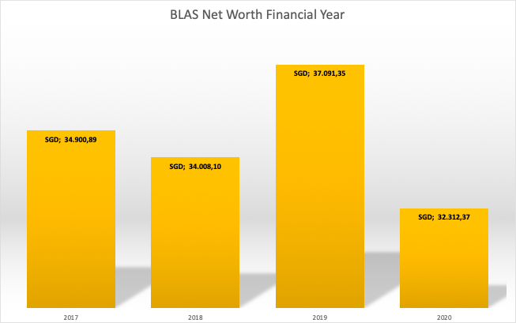

  - Accounts overview

- Balances: 1 May 2020 - 30 April 2020 (activity year)

- BLAS Total SGD 31.158,37

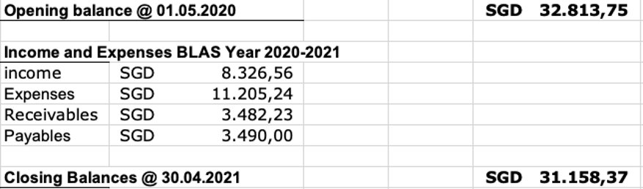

  - Income & Expenses

01/05/20 to 30/04/21
 | IN | OUT | NETT
Membership | 6.246,93 | 315,00 | 5.931,93
Admin | 1,00 | 83,80 | -82,80
Website | 0,00 | 3.980,00 | -3.980,00
Funteam | 0,00 | 1.148,54 | -1.148,54
Charity | 0,00 | 500,00 | -500,00
Advertising & Communication | 0,00 | 751,90 | -751,90
G2G | 115,46 | 2.202,20 | -2.086,74
Quiz | 226,27 | 156,00 | 70,27
Culture | 1.055,55 | 1.080,00 | -24,45
Sports | 0,00 | 0,00 | 0,00
Kids Club | 55,26 | 322,80 | -267,54
Cooking | 626,09 | 665,00 | -38,91
Welcome | 0,00 | 0,00 | 0,00
Petty cash | 0,00 | 0,00 | 0,00
BLAS | 8.326,56 | 11.205,24 | -2.878,68

- Election Night (Patricia Vermast)

The following members have been proposed and seconded. They have indicated their willingness to stand for election and were elected:

  - Office Bearers

- President: Wesley Boers
    - Proposer: Patricia Vermast
    - Seconder: Els Wille

- Vice-President: Caroline Verlinden
    - Proposer: Els Wille
    - Seconder: Laure-Anne Krug

- Secretary: Els Wille
    - Proposer: Ingeborg Neels
    - Seconder: Gino Delaere

- Treasurer: Laure-Anne Krug
    - Proposer: Katleen Missiaen
    - Seconder: Anne De Weert

  - Other Committee Members

- Katleen Missiaen
    - Proposer: Tom Bollaert
    - Seconder: Ingeborg Neels

- Ingeborg Neels
    - Proposer: Els Wille
    - Seconder: Katleen Missiaen

- Liesbeth Van Baelen
    - Proposer: Ingeborg Neels
    - Seconder: Patricia Vermast

- Moniek Kasbergen
    - Proposer: Caroline Verlinden
    - Seconder: Jacques Breyer

- Few words by outgoing Ad Iterim President (Patricia Vermast)

- Few words by incoming President (Wesley Boers)

- Closing (Patricia Vermast)

The meeting closed at 20.40.

For Approval,

Wesley Boers  President | Caroline Verlinden  Vice-President
Els Wille  Secretary | Laure-Anne Krug  Treasurer

Appendix A – Participating Members

# | Last Name | First Name | Attendance List
1 | Adriaens | Bart | present
2 | Alvarez | Isabelle | present
3 | Boers | Wesley | present
4 | Bollaert | Tom | present
5 | Breyer | Jacques | present
6 | De Haeck | Ria | present
7 | De Weert | Anne | present
8 | Delaere | Gino | present
9 | Eijckmans | Bart | present
10 | Goris | Wim | present
11 | Kasbergen | Moniek | present
12 | Kempenaer | Ivo | present
13 | Krug | Laure-Anne | present
14 | Mesters | Sander | proxy to C. Verlinden
15 | Missiaen | Katleen | present
16 | Neels | Ingeborg | present
17 | Reynders | Karl | present
18 | Van Baelen | Liesbeth | present
19 | Van den Heede | Filip | present
20 | Van Leynseele | Jacques | present
21 | Van Steenbergen | Thomas | present
22 | Verlinden | Caroline | present
23 | Vermast | Patricia | present
24 | Wille | Els | present
25 | Wouters | Patrick | present

